**Bridgeland Main Street Phase One: 2022 End-of-Season Construction Update**

The first phase of the Bridgeland Main Streets project is nearing the end of its first season. Throughout the season, construction was focused between Memorial Drive and 2 Avenue N.E. with work primarily located along Edmonton Trail, and the Gateway area near Memorial Drive.

The work areas on the north and south adjacent blocks of 1 Avenue N.E. are nearly complete, with the remaining work to include the sod and tie-in work, which is expected to be complete later this fall. Work at the Gateway area near Memorial Drive has seen unexpected delays, and we thank the businesses and visitors to the area for their patience while we continue to navigate those unknown utilities and supply chain delays. We expect to have most of the work complete this season, with sod and final landscaping expected in 2023.

Work completed this season helps to realize the final vision of the Bridgeland Main Street. Some of the work you will notice includes:

* Widened sidewalks on the East and West side of Edmonton Trail.
* More plants and trees along with improved green space
* New Streetlights, crosswalks, and improved accessibility at intersections, such as tactile plates

In the map below, you will see the green sections which are expected to start in the spring of 2023. We anticipate that work will start at the north end, near 2 Avenue N.E. As a note, construction is variable, and the schedule is subject to change depending on factors such as complexity, weather, supply chain, and access.

In the coming months, Bridgeland BIA and Businesses can expect to hear from the Bridgeland Main Streets team again in the early Spring to discuss impacts and mitigations for construction activity planned next year.

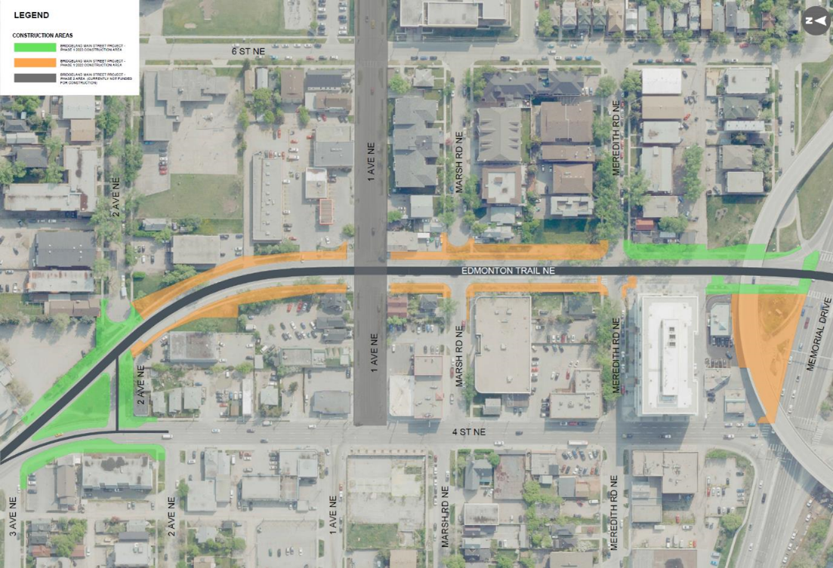

*Before and After: Edmonton Trail north of Meredith Road.*

