

**Executive Director**

**Projects 2023**

1. Gateway and Main Street Project
   1. Liaising with the City with Gateway and Main Streets
      1. Gateway way project start date summer 2022, completion spring 2023 – 70% complete
      2. Main Street project start date spring 2023, completion fall 2024 – this is an unfunded project and goes to council for funding approval in the November 2022

**Bridgeland Main Street Phase One: 2022 End-of-Season Construction Update**

The first phase of the Bridgeland Main Streets project is nearing the end of its first season. Throughout the season, construction was focused between Memorial Drive and 2 Avenue N.E. with work primarily located along Edmonton Trail, and the Gateway area near Memorial Drive.

The work areas on the north and south adjacent blocks of 1 Avenue N.E. are nearly complete, with the remaining work to include the sod and tie-in work, which is expected to be complete later this fall. Work at the Gateway area near Memorial Drive has seen unexpected delays, and we thank the businesses and visitors to the area for their patience while we continue to navigate those unknown utilities and supply chain delays. We expect to have most of the work complete this season, with sod and final landscaping expected in 2023.

Work completed this season helps to realize the final vision of the Bridgeland Main Street. Some of the work you will notice includes:

* Widened sidewalks on the East and West side of Edmonton Trail.
* More plants and trees along with improved green space
* New Streetlights, crosswalks, and improved accessibility at intersections, such as tactile plates

In the map below, you will see the green sections which are expected to start in the spring of 2023. We anticipate that work will start at the north end, near 2 Avenue N.E. As a note, construction is variable, and the schedule is subject to change depending on factors such as complexity, weather, supply chain, and access.

In the coming months, Bridgeland BIA and Businesses can expect to hear from the Bridgeland Main Streets team again in the early Spring to discuss impacts and mitigations for construction activity planned next year.

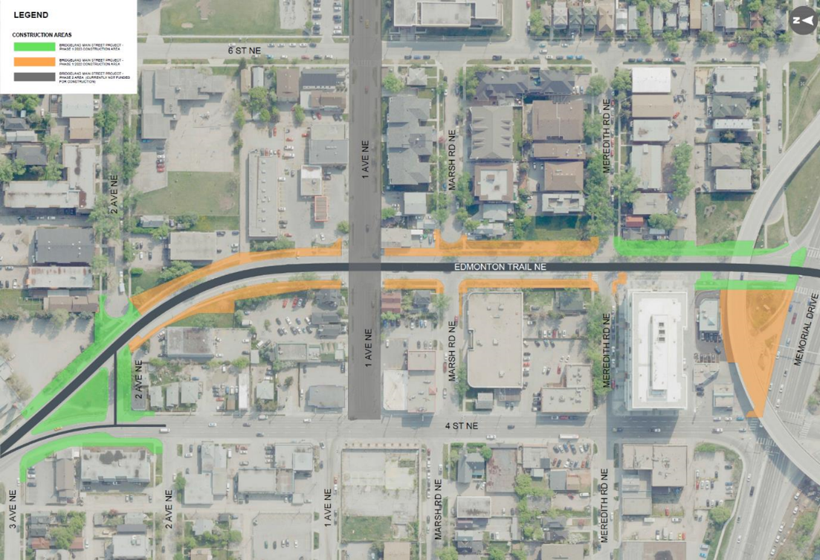

*Before and After: Edmonton Trail north of Meredith Road.*

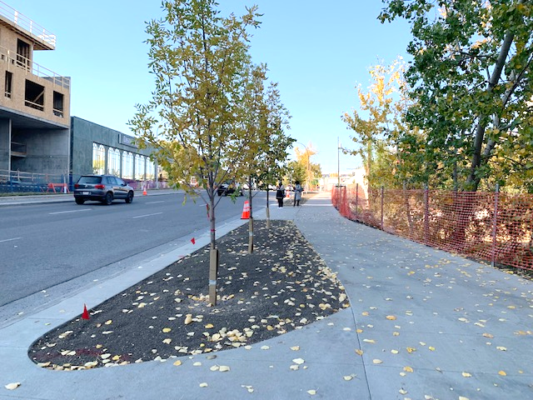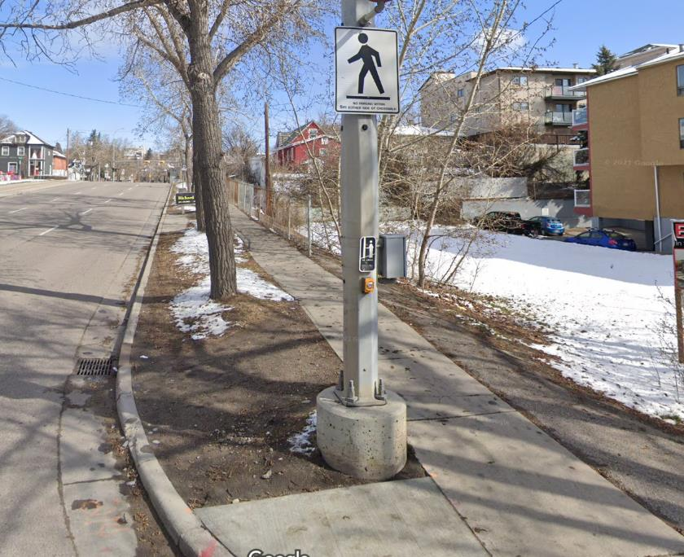

1. 12th Street NE Bridge project

12 Street N.E. bridge. The way Calgarians get around is changing: more people are choosing to walk, scoot, skateboard, or cycle and we want to provide convenient and attractive transportation choices for Calgarians of all ages and abilities. The City has identified this bridge for improvements based on recent residential development at the east end of Bridgeland and a potential correlated increase in active mode users, as well as updated accessibility and transportation standards. This project will provide a wider sidewalk for walking and wheeling along the bridge, improved pedestrian crossings, and a better connection within the pathway and bikeway network. See ([Calgary.ca/12STNE](https://www.calgary.ca/roads/construction/12-st-ne-mobility.html)). Start date fall 2022, completion date winter 2022.

1. Community Stewardship
   1. Steward the levy paid by member businesses through advocacy, building strong relationships, promotion, leading and championing programs and investments that make Bridgeland a destination of choice and economic center that supports the entire community
   2. Develop and manage Bridgeland Brand and Reputation
   3. Participate in evolution of pedestrian and vehicle access and interactions within the community
2. Website Updates
   1. Distribution information to the membership
   2. Drive traffic to the Bridgeland website to promote local business
3. Marketing Plan 2023
   1. Promote Bridgeland as a destination of choice and economic center that supports the entire community
4. Engage and develop relationship with BRCA
   1. Support mutually beneficial beautification initiatives
   2. Engage with the BRCA on initiatives and events that drive patronage to the local businesses.
5. Beautification projects
   1. Banners on Edmonton Trail



* 1. Bike racks

Concept designs – highlight our locally owned businesses with unique bike rack designs and using the brand’s patchwork system to create colorful bike racks throughout the community.

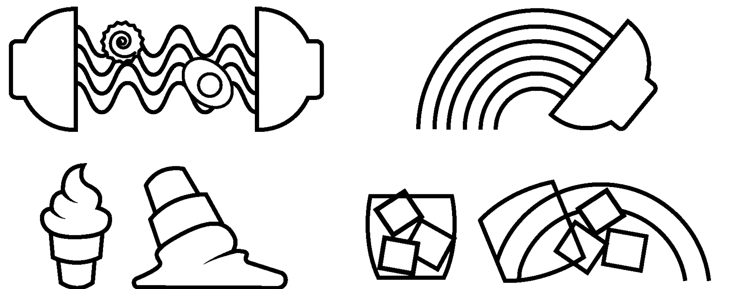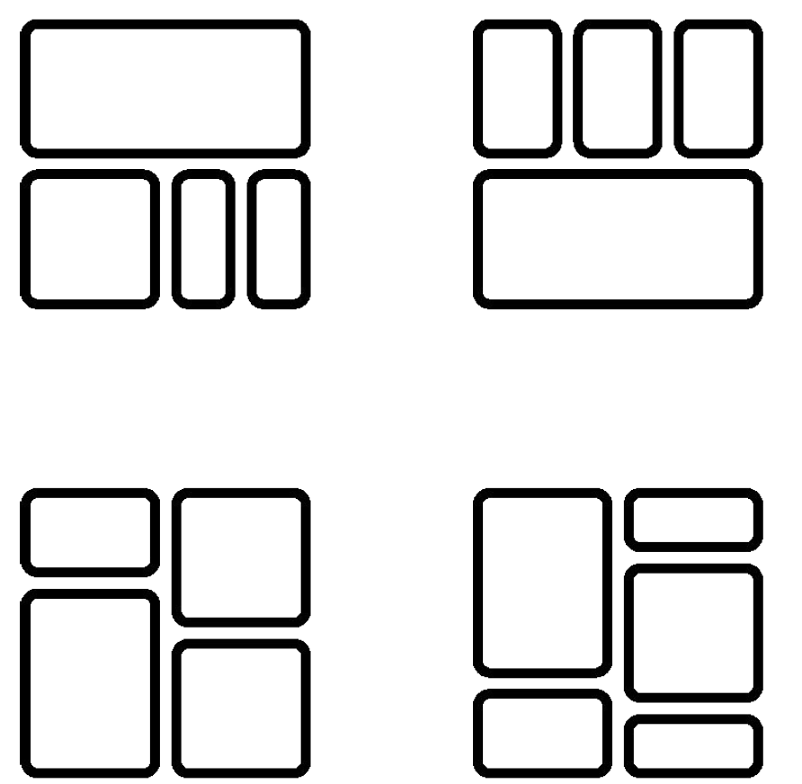

* 1. Murals

4 murals will be installed in the cement pillars on the fly over

1. Paid Parking

The BIA is working with the City to find paid parking lot opportunities to increase parking options for the customers.