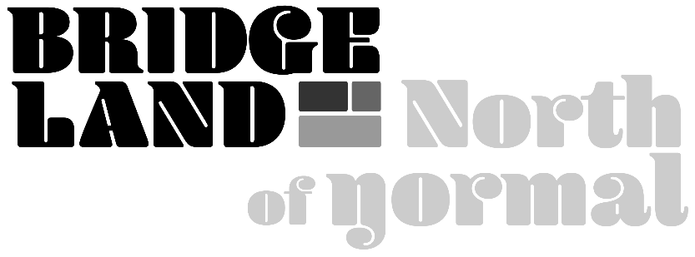

**BIA President Report**

As we say goodbye to the summer season and welcome the new autumn colors businesses gear up for the holiday with new exciting stock, marketing plans, and the inevitable additional cleaning requirements. This seasonal change always promises things to look forward to with some apprehension and perhaps a mourning of the summer gone. Similarly, Calgary continues to change, flourish, and grow through major developments, infrastructure, new community building, and densification. These changes are well reflected in our community of Bridgeland with our own major developments, infrastructure changes, and new residents and business owners. With much to look forward to, change inevitably comes with some challenges.

The Bridgeland BIA welcomes the new businesses to our “village within a city”. We can expect to see hundreds of new residents with new towers nearing completion, many of which have commercial spaces that will help to build a business core that supports the entire community. Densification allows more businesses to flourish in a smaller area and also welcomes a greater disbursement of levies.

This year the BIA has focused primarily on infrastructure and planning, supporting the City of Calgary through three key projects: The Gateway Project, Mainstreet, and the 12th Street Bridge. Construction almost always causes disruptions, but the changes being made are very promising; many new trees have been planted, pedestrian and bike traffic improved, beautification projects, and security with new lighting will all be present. We have done work to keep the impact of development on businesses to a minimum and will continue to do so as some of these projects span years.

Anyone that lives or works in Bridgeland knows we have a “certain something” here; we welcome the Bridgeland brand and guidelines to our community creating a congruent, prosperous, and unique district within the greater fabric that is Calgary. Expect to find new murals, flags and lighting, and other community-based projects such as seating, bike parking, and community fire pits all with a uniquely Bridgeland touch.  We acknowledge the need for character preservation and historical designation, too. Working with community members, ensuring thoughtful development, and acknowledging historical sites are all within the BIA’s scope. Safety and social issues remain a top priority, along with community building and wayfinding. We are working with the City of Calgary and the Community Association to create solutions.

Change also means we expect new, fresh board members to continue the strategic plan and vision our founding board members worked on throughout the pandemic. We look forward to the next season of this not-for-profit in ways that better our business community.