**Stage 1 Pre-settlement**

The buffalo traversed the Bow River at its shallow area near the present day Reconciliation Bridge. Indigenous people roamed through this area, hunting, camping and crossing the river as well. The area was treeless with the exception of the banks of the Bow River

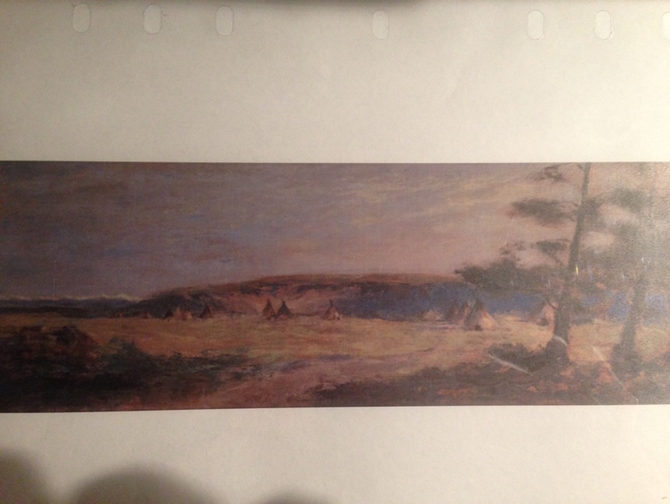

Painting near Calgary by John Hammond late 1800’s

**Stage 2 Early Settlement of Riverside 1890’s - 1914**

Riverside was initially an informal settlement on the north side of the Bow River, outside Calgary city limits, primarily with immigrants from a number of European countries. The building of the first Langevin Bridge in 1888 spurred settlement and the area became known as Germantown.. The important trail to Edmonton became the locus of ongoing development and Riverside became a village in 1902, with boundaries extending from the river to 6 St and as far north as 8th Ave. Calgary’s population boom in the early 1900’s meant even more settlement along this busy transportation corridor and by 1910 significant development was happening in nearby Bridgeland including the Calgary General Hospital, Fire Hall #4, Riverside Public School, along with a new Steel truss Langevin Bridge and a streetcar route along 4th Street and to the hospital. Many 2 and 3 storey buildings were being constructed including Riverside Hotel, Sligsby Block, Armour Reliance Block, Poffenroth/ DeWaal block and north of 1st Avenue was Gallelli Block and Roma Grocery. Industries were also established such as Pioneer Stables, Riverside Ironworks and Riverside Steam Laundry (west of 4th Street) and Riverside Lumberyard to the east along Boulevard Avenue. Small grocery stores, shoe repair and barber shops, drug stores and department stores opened at street level, serving the many new immigrants who were settling on both sides of 4th Street. Many languages were spoken by the German, Ukrainian, Italian, Jewish and Chinese residents who joined with nearby Bridgeland (which had been annexed to the city in 1907) to form the Bridgeland -Riverside Athletic Association. The area was busy with people, horses, streetcars and many young children. Riverside was annexed to the city in 1910 and growth continued until 1914 when WW1 started. Most further development was curtailed in the area until the 1950’s.

It must be mentioned that Riverside and to some extent Bridgeland had a somewhat negative reputation – possibly due to the largely different/ immigrant population, the early presence of brothels in the area of 6th Street and occasional accusations of gambling houses. This may have had a negative impact on the longer term view of Riverside as the community’s name did not appear on formal city maps after this time.

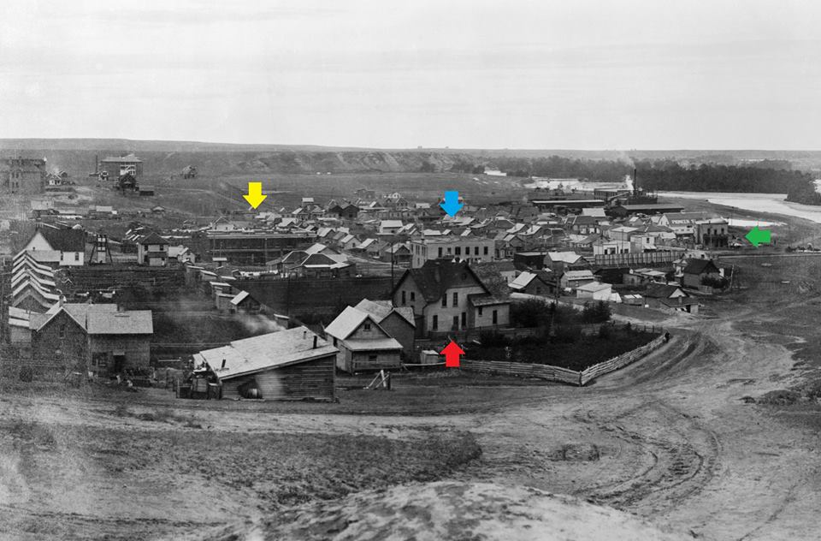

Riverside looking eastward from Meredith/ hill - 1914

**Stage 3. Post war 1950’s – 1990’s**

Many new immigrants arrived from Europe after the war, often staying and settling in Riverside and Bridgeland with the local population increasing to its highest point at 6800 people in the late 1960s. The boundary between the 2 originally distinct communities changed and blurred considerably. Nearby schools were full and business developments along 4th Street included a thriving furniture district which featured Alberta Furniture, Roxton’s Furniture and Eisenberg’s Fine Furniture. The department stores and food/ confectionaries continued to do a good business.

Calgary’s population growth into far flung suburbs led to a need for better corridors for cars going to the downtown and this resulted in major changes for Riverside. The East Memorial Drive Project (1970’s) prompted the widening of Memorial Drive from a 2 way minor road into a 6 lane freeway that became even wider with the building of the C Train into the north part of Calgary in the 1980’s. Easy access for residents to the river was gone. To accommodate traffic exiting the downtown, the East Langevin Bridge (later known as the 5th Avenue Flyover) was built and a northward extension through Riverside resulted in the new 4 lane Edmonton Trail. Fourth Street, from 2nd Ave to the Bow River was converted to a oneway 4 lane thoroughfare. The 4th Avenue Flyover was built to take volumes of traffic into the downtown.

There were significant consequences for Riverside- the appropriation and removal of many homes and the loss of the pedestrian friendly streetscape of 4th Street. The city’s rezoning of land west of 4th Street resulted in the removal of more single family homes to build apartment buildings. The community was in decline and considered a depressed area, receiving grants from the Neighbourhood Improvement program (NIP). The first Bridgeland Riverside Area Development (1980) program sought to invigorate Bridgeland – Riverside and make it more family friendly and prosperous.

|  |  |
| --- | --- |
| 1970s | 2022 |

**Stage 4 2000’s onward**

Riverside has continued to be a shadow of its former self and few businesses were operating along 4th street into the 2000’s. The nearby East Village and Bridgeland / 1st Ave and 9 Street have seen a resurgence, with growing interest in living in the inner city and the re-purposing of heritage buildings. The Benevity Block and Era condo’s are starting to have an impact on the area, bring new people to work and live. The “bones” of a heritage district still exist in Riverside and the stories of the past are not hard to find. Riverside is a place of great potential. How long will it take for this colourful, historic district to regain its past energy and presence?